Lub ntsiab lus: Kev Tsim Kho Ntawm Pawg Sab Laj Ntawm Pej Xeem Hauv Nroog Fresno Hnub Tim 10.6.21 (Fresno County Residents Council Update)

Nqe lus piav qhia (Tagline): Kev qhia #2 Ua Raws thiab Cov Kauj Ruam Tom Ntej

Nyob zoo

Kuv vam hais tias koj ua tau zoo thiab nyob nyab xeeb. Nws yog qhov zoo siab uas tau pom feem coob nrog koj ntawm qhov kev qhia zaum ob ntawm Pawg Sab Laj Ntawm Pej Xeem Hauv Nroog Fresno - " Zej Zog Kev Koom Tes "! Hauv kev qhia #2, peb tau kawm:

* Qhov tseem ceeb ntawm kev tsim kev sib raug zoo rau pej xeem txhawm rau tsim kev koom tes hauv zej zog kom muaj zog.
* Peb tuaj yeem tsim kev ntseeg siab ntawm cov kev sib raug zoo los ntawm lub rooj sib tham ib-toj-ib uas hu ua kev sib tham sib raug zoo.
* Peb tuaj yeem paub tias dab tsi yog qhov tseem ceeb rau nqee leej neeg los ntawm kev ua raws lis "[Daim Duab](https://drive.google.com/drive/u/0/folders/1KJB0B6vReIQjxKavFtKeT3dgMRvLhSCY)" uas yog tus qauv uas piav qhia ntau hom kev sib raug zoo thiab kev sib raug zoo uas nqee leej neeg tuaj yeem muaj.
* Peb yuav tsum nrhiav kev tsim kho ntawm kev sib raug zoo nrog lwm tus ua ntej uas peb tuaj yeem pib ua hauj lwm daws teeb meem ib puag ncig hauv peb lub zej zog kom tau zoo nyob.

**Ceeb Toom (Reminder):** Yog tias koj tsis tuaj yeem koom nrog kev qhia, koj tuaj yeem  [saib cov yeeb yaj kiab (watch the video](https://drive.google.com/drive/u/0/folders/1DpVOGFkhUktEQkAaywxT9bVtxXllTFhH))! Qhia rau koj Lub Koos Haum Anchor paub tias koj tau saib cov yeeb yaj kiab tag nrho lawm txhawm rau kom nws suav nrog tias yog koj li kev tuaj koom.

*Koj tuaj yeem saib Kev nthuav qhia PowerPoint, cov kev kaw, thiab cov ntaub ntawv los ntawm "Meeting Documents" lub pob taum hauv qab no (button below).*

***Txoj Hauj Lwm Uas Ua Tom Tsev Nyob Rau Lub Hlis No (This months homework assignment)*** *yog txhawm rau txuas nrog lwm tus neeg hauv koj Lub Koos Haum Anchor los sis lwm tus tswv cuab ntawm Pawg Sab Laj thiab muaj kev sib tham ib-toj-ib uas siv cov ntsiab lus thiab daim duab uas peb tau qhia rau koj thaum lub sij hawm qhia.* ***Thov nco ntsoov xa koj cov hauj lwm tom tsev mus rau koj Lub Koos Haum Anchor ua ntej hnub Wednesday, Hnub Tim 13 Lub Kaum Hli.***

*Peb xav rov hais dua txog cov lus txawj ntse ntawm Hope Flint uas los ntawm peb lis Kev Qhia rau Hnub Tuesday:*

*"* *Pej xeem tuaj yeem tuaj koom qhov kev txhawb siab, tab sis lawv yuav TAUG KEV (MARCH) txhawm rau kev sib raug zoo."*

Peb qhov kev qhia tom ntej yuav yog hnub Tuesday, Hnub Tim 19 Lub Kaum Hli thaum 5: 30-7pm los sis Hnub Saturday, Hnub Tim 23 Lub Kaum Hli thaum 10-11: 30am. Txhua qhov kev qhia yog phaj Zoo Li Tiag hauv ZOOM (Virtual sessions on ZOOM).

Nco ntsoov sau npe ntawm kev xaiv hnub uas koj tuaj yeem tuaj koom nrog hauv qab no. Txog ntawm kev pab cuam txhais lus, koj yuav tsum sau npe ua ntej hnub Friday, Hnub Tim 15 Lub Kaum Hli thiab qhia rau peb paub tias koj xav tau kev txhais yam lus twg.

**SAU NPE RAU HNUB FRIDAY HNUB TIM 15 LUB KAUM HLI**

**SAU NPE RAU HNUB FRIDAY HNUB TIM 15 LUB KAUM HLI**

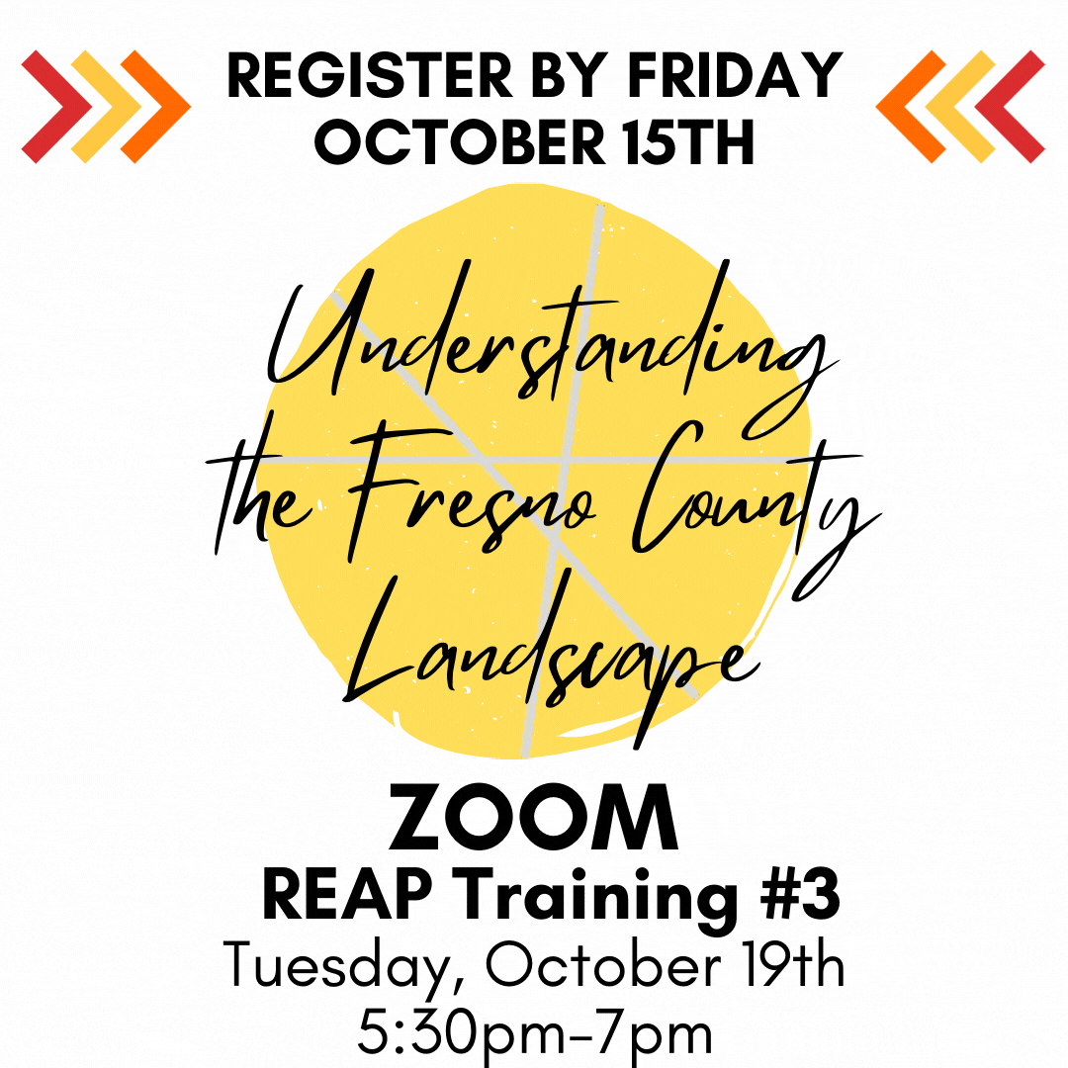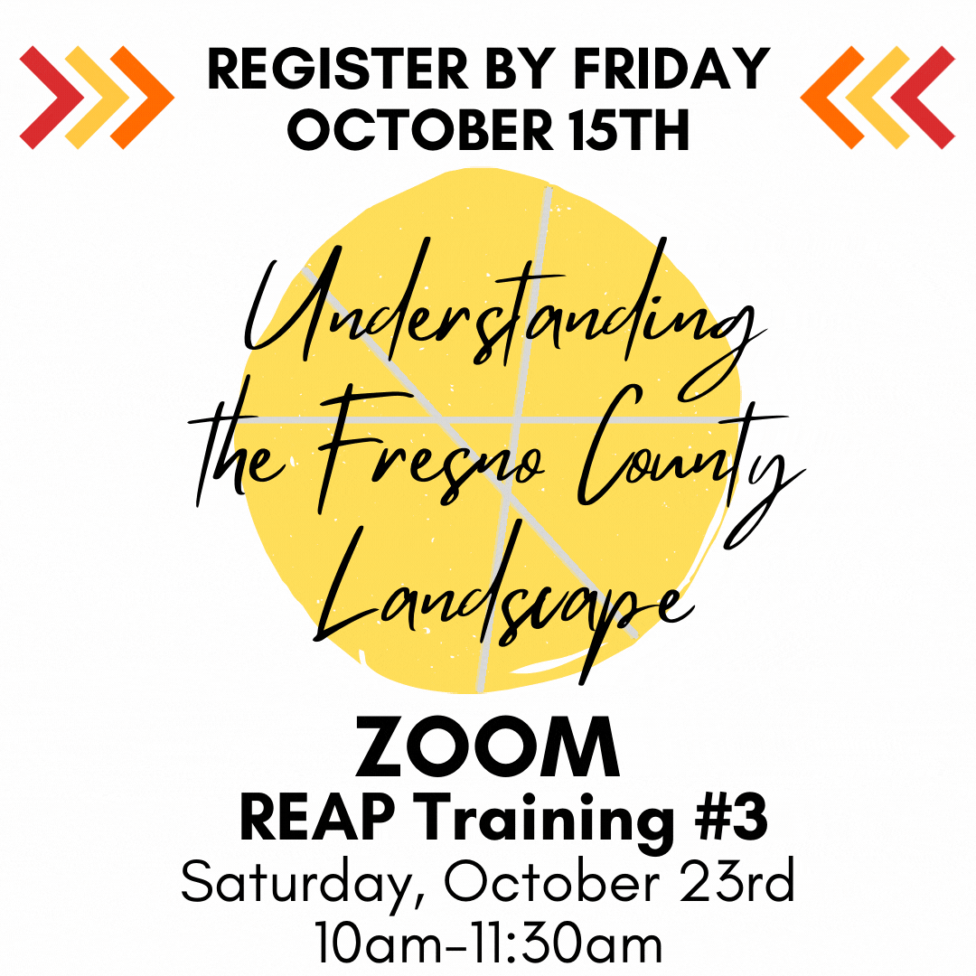

**Kev Qhia Uas KHAW HAUV ZOOM #3** Hnub Saturday, Hnub Tim 23 Lub Kaum Hli thaum 10am-11:30am

**Kev Qhia Uas KHAW HAUV ZOOM #3** Hnub Tuesday, Hnub Tim 19 Lub Kaum Hli thaum 5:30pm-7pm

Thaum peb tseem taug txoj kev no ua ke, peb xav kom paub tseeb tias Nroog Fresno paub txog cov hauj lwm uas peb tab tom ua. Peb xav khaws cov duab thiab yeeb yaj kiab los qhia zaj keeb kws ntawm thawj zaug, Pawg Sab Laj Ntawm Pej Xeem Hauv Nroog Fresno. Txhawm rau suav nrog hauv zaj keeb kws digital no, thov nco ntsoov ua kom tiav thiab xa [Daim Foos Tshaj Tawm Xov Xwm](mailto:Daim%20Foos%20Tshaj%20Tawm%20Xov%20Xwm%20)  rau [pen@tcmfresno.org](mailto:pen@tcmfresno.org).

Peb tos ntsoov yuav ntsib koj sai sai no!

Hauv Zej Zog,

Mike Espinoza

Tus Thawj Coj, Kev Tsiv Mus Los Ntawm Cov Me Nyuam Yaus Hauv Nroog Fresno